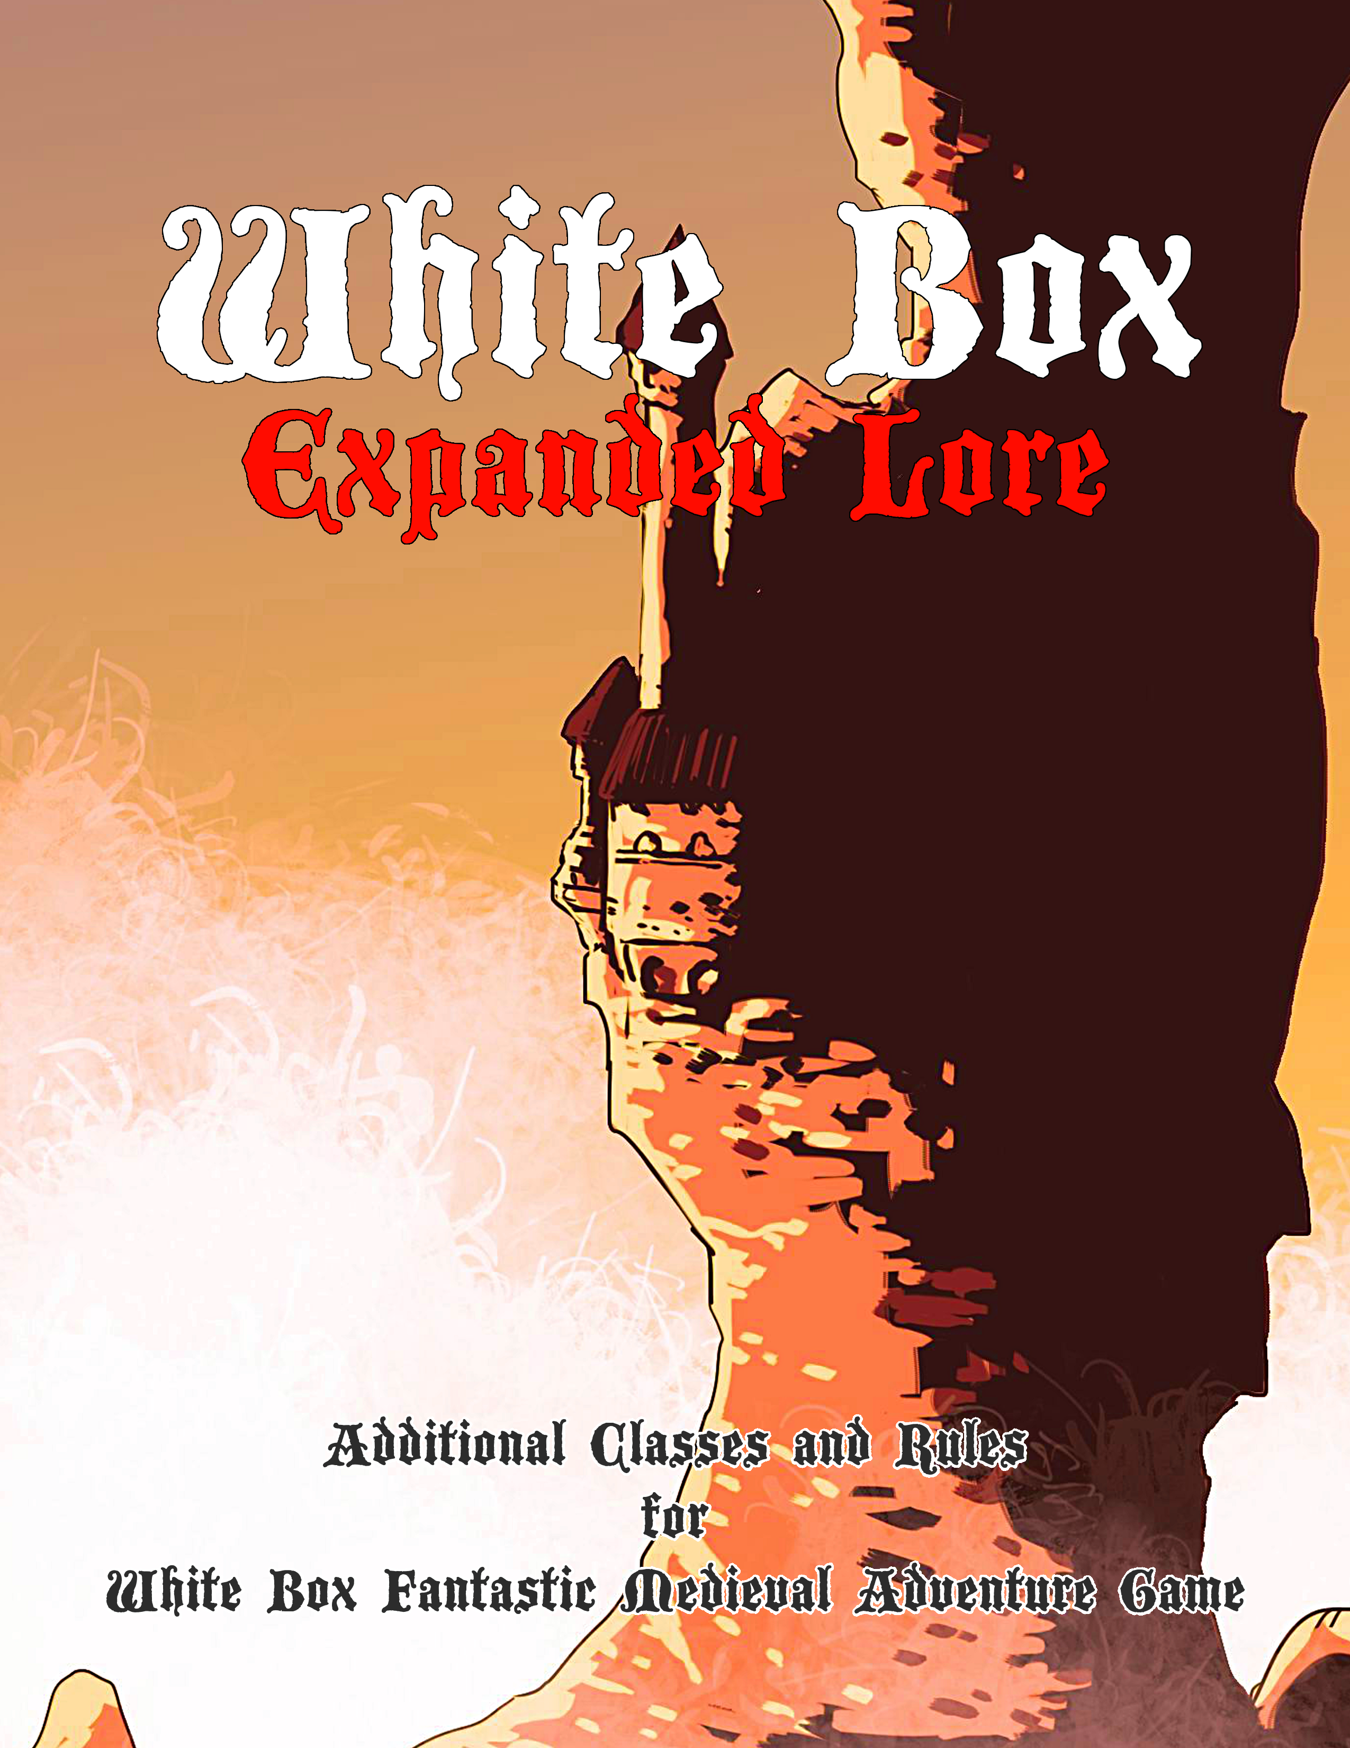
Table of Contents
Introduction 4
The Bard 5
Bard abilities 5
The Druid 7
Druid abilities 8
The Hunter 10
Hunter abilities 10
The Monk 13
Monk abilities 13
The Paladin 15
Paladin abilities 15
Druid Spells List 17
Air Walk 18
Animal Messenger 18
Awaken Treant 18
Berries 19
Call Lightning 19
Call Monster 19
Charm Animal 20
Flare 20
Fog 20
Know Weather 21
Locate Animal 21
Locate Snares and Pits 21
Protective Circle 22
Quake 22
Summon Animal 22
Sunburst 23
Tree Stride 23
Warp Wood 23
Wild Strength 24
Wind Wall 24
Expanded Rules 25
Attributes 25
Attribute Bonuses and Effects 25
Bonus XP 26
Checks 26
Critical Hits and Failures 26
Dual-Wielding 27
Less Harsh Deaths 27
Attribute Improvement 27
Exotic Weapons 27
Races 28
Additional Abilities 29
Bard 29
Cleric 29
Druid 29
Hunter 29
Fighter 30
Magic-user 31
Monk 31
Paladin 31
Thief 31
Feats 32
General Feats 32
Bard Feats 32
Cleric Feats 33
Druid Feats 33
Hunter Feats 34
Fighter Feats 34
Magic-User Feats 35
Monk Feats 35
Paladin Feats 36
Thief Feats 36
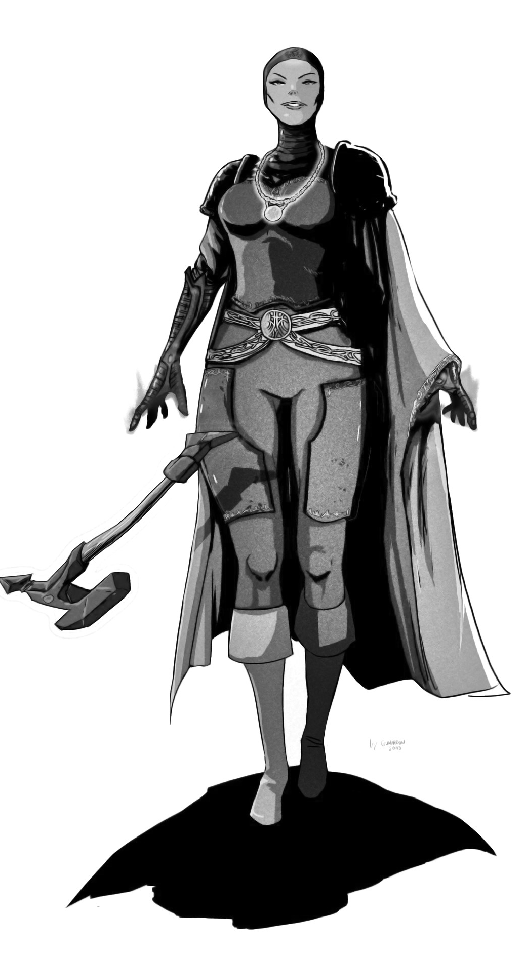
Author
Simon “Noobirus” Piecha

www.facebook.com/noobirus

Art
GunarDAN

Special Thanks To
Karol Ulatowski, Łukasz Kołodziej, Paweł „PaulMorningstar” Jendrych, Jonathan Rowe from www.fenorc.co.uk and Charlie Mason

Compatible with Swords & Wizardry: WhiteBox
Designed for
White Box by Charlie Mason

Version 2.1 | 2020

“Swords & Wizardry, S&W, WhiteBox, and Mythmere Games are the trademarks of Matthew J. Finch,” Simon Piecha and Jaskinia Noobirusa is not affiliated with Matthew J. Finch or Mythmere Games™.

Introduction
Greetings traveler! The book you are currently reading is a compilation of five additional classes – the Bard, Druid, Hunter, Monk, and Paladin – with house-rules, that you can use in your White Box game.
It is worth mentioning, that the classes and rules presented here were designed specifically for the White Box game released by Charlie Mason. This means that they are balanced and simplified in order to work well with the original four classes – the Fighter, Magic-User, Cleric, and Thief.
However, the additional rules strongly modify the core rules of the White Box game and are designed for long campaigns. They are very optional and most purists may see them as too modern. Still, they are designed to keep the game simple and fun.
I hope you will enjoy reading this supplement, as much as I had writing it for my campaign.
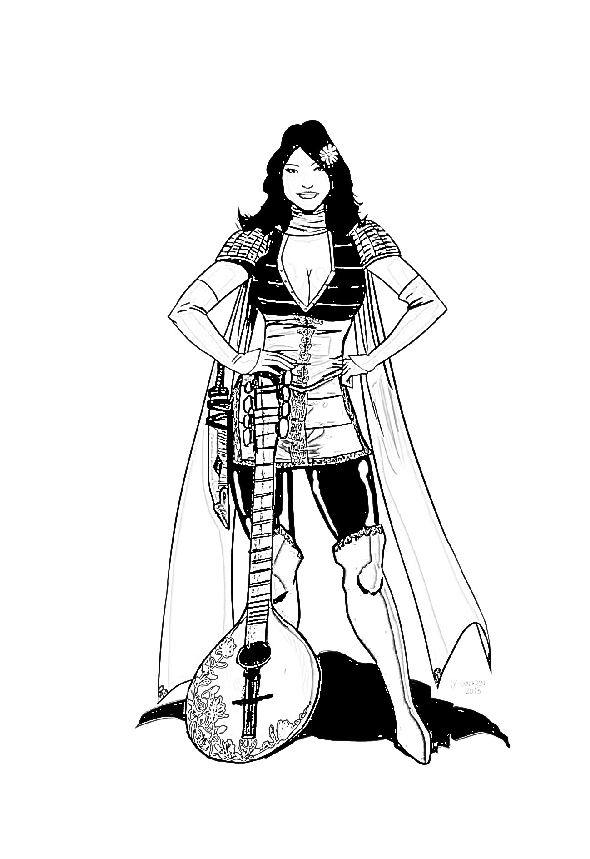

The Bard
Minstrels, artists, poets... bards come in many names. You will meet them in most taverns where they sing songs about mighty dragon slayers and mystical lands far beyond the known horizon.
Bards are pure-blooded adventurers and treasure hunters... or to be more precise - adventure hunters. Bards are knowledgeable in many areas and are keepers of lore. They play a supportive role in the party – they may be not that strong in battle, but they are masters when it comes to solving puzzles, revealing secrets, or bartering with non-player characters.
Bard Advancement
Level | Exp.  Points | Hit  Dice | To  Hit | Saving Throw | Lore
1 | 0 | 1 | +0 | 14 | 2
2 | 1,250 | 1+1 | +0 | 13 | 2
3 | 2,500 | 2 | +0 | 12 | 2
4 | 5,000 | 2+1 | +1 | 11 | 3
5 | 10,000 | 3 | +1 | 10 | 3
6 | 20,000 | 3+1 | +1 | 9 | 3
7 | 40,000 | 4 | +2 | 8 | 4
8 | 80,000 | 4+1 | +2 | 7 | 4
9 | 160,000 | 5 | +2 | 6 | 4
10 | 320,000 | 5+1 | +3 | 5 | 5

Bard abilities
Weapons and Armor Restrictions
Bards are weak in battle. They cannot use heavy, two-handed weaponry (this also includes heavy ranged weapons), and may only wear leather armor.

Charm
Every bard has a musical instrument – describe yours to your Referee. At any time you may play a magical song that charms monsters with HD lower or equal to your level. You may also divide this effect among multiple weaker monsters (for example: a level 5 bard may charm five HD 1 monsters). As long as you play your instrument, the charmed monsters will follow you and won't do any harm. If you get distracted, hit, or the monsters are attacked by the party – the charm is broken and the song won't work again.
You can't charm undead, demons and monsters that can't hear.

Lore
Bards have a deep knowledge of different things – legends, magic, and creatures. Whenever the bard finds something strange, for example: an unidentified magical item, or unknown site, the Referee rolls a d6. If the result of the roll is equal to or lower than the bards rating in the lore ability, the Referee reveals useful information about the object or site. Otherwise, the Referee tells the bard a lie.

Saving Throw
Bards receive a +2 bonus on saving throws vs. charms (for example, those done by dryads).

Legend
A bard of ninth or higher level may write a book that tells legends about the heroic deeds of the party. These legends are now known thorough the land, and the party receives great fame – they are recognized in every town in the world.

Experience Bonus for Charisma
Charisma is the Prime Attribute for Bards, which means that a Charisma score of 15+ grants an additional 5% experience.

The Druid
In contrast to the Clerics or Magic-Users, Druids do not take their power from the gods or mystical scriptures. Druids worship nature and the natural order of things.
Druidic magic comes from Mother Nature – the elements, plants, and animals. They have their own spell list. Druids are always neutral and tend to avoid civilized areas.
Druids have less spells then Magic-Users and aren't trained in warfare as Clerics, but their special abilities allow them to survive in the wilderness and dungeons longer.
Druid Advancement
Level | Exp.  Points | Hit  Dice | To  Hit | Saving Throw
1 | 0 | 1 | +0 | 15
2 | 2,500 | 1+1 | +0 | 14
3 | 5,000 | 2 | +0 | 13
4 | 10,000 | 2+1 | +1 | 12
5 | 20,000 | 3 | +1 | 11
6 | 40,000 | 3+1 | +1 | 10
7 | 80,000 | 4 | +2 | 9
8 | 160,000 | 4+1 | +2 | 8
9 | 320,000 | 5 | +2 | 7
10 | 640,000 | 5+1 | +3 | 6

Druid Level | Spells
 | 1 | 2 | 3 | 4 | 5 | 6
1 | - | - | - | - | - | -
2 | 1 | - | - | - | - | -
3 | 2 | 1 | - | - | - | -
4 | 2 | 2 | - | - | - | -
5 | 2 | 2 | 1 | - | - | -
6 | 3 | 2 | 2 | - | - | -
7 | 3 | 3 | 2 | 1 | - | -
8 | 3 | 3 | 2 | 2 | - | -
9 | 3 | 3 | 3 | 2 | 1 | -
10 | 3 | 3 | 3 | 3 | 2 | 1

Druid abilities
Weapons and Armor Restrictions
Druids may use daggers and any wooden weapon. They may only wear leather armor.

Spell Casting
Druids cast druidic spells from a specific spell list, as per the Druid Advancement table. Each day the Druid meditates for a certain set of spells, choosing any spell from the standard list.

Shape Change
Once per day the druid may change his shape to either a small animal, or a bigger, more ferocious one. The druid may change back to his normal form at any time. While creating your character, consult with your Referee which small animal (for example: lizard, raven) and which big animal (for example: bear, wolf) you may change into.
In your small animal form you cannot speak, you lose all equipment, cannot use any items and fight, but you are more agile and you may reach places inaccessible to normal humanoids.
In your big animal form you cannot speak, you lose all equipment and cannot use any items, but you deal 1d6+1 damage with your natural weaponry and your AC improves by -4 [+4].
Druids cannot cast spells while in their animal shape, since they cannot speak and have no hands.

Saving Throw
Druids receive a +2 bonus on saving throws vs. element-based effects and attacks.
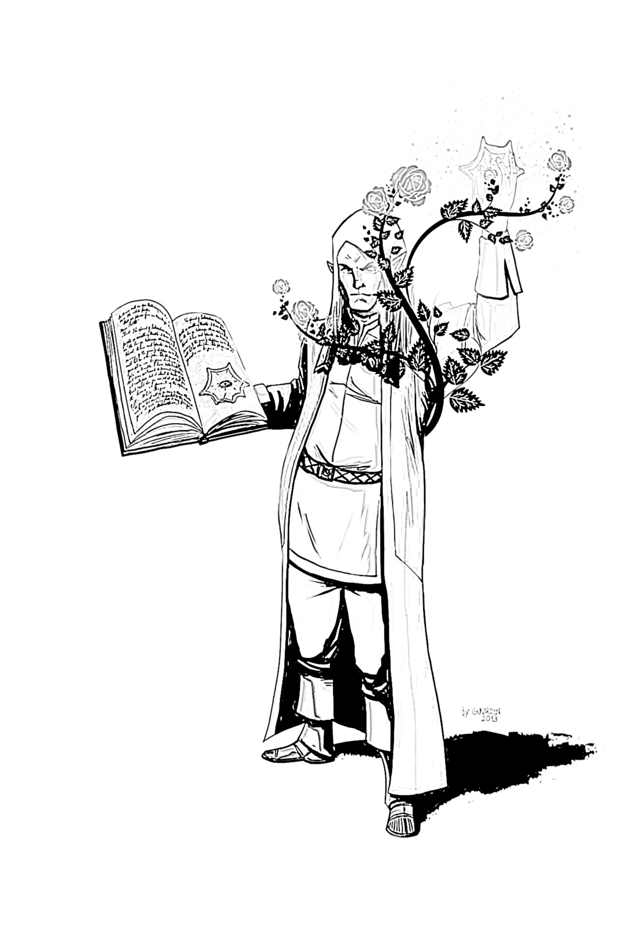
Sacred Grove
A druid of ninth or higher level may become an Elder Druid and the guardian of a sacred grove. The druid must find such a grove and meditate under the largest tree for one day in order to archive this status.
After becoming a guardian, the grove attracts many fantastic creatures, that are friendly to the druid and will help him protect the nearby land. Such creatures include – elves, faeries, dryads and treants.

Experience Bonus for Wisdom
Wisdom is the Prime Attribute for Druids, which means that a Wisdom score of 15+ grants an additional 5% experience.

The Hunter
In contrast to Fighters and Paladins, Hunters do not spend their time on mastering weapons, martial arts or seeking glory. Instead, these heroes study the life and biology of monsters... to find a way to kill them as quickly as possible. Hunters prefer to stalk their prey, and fight enemies using ranged or long weaponry.
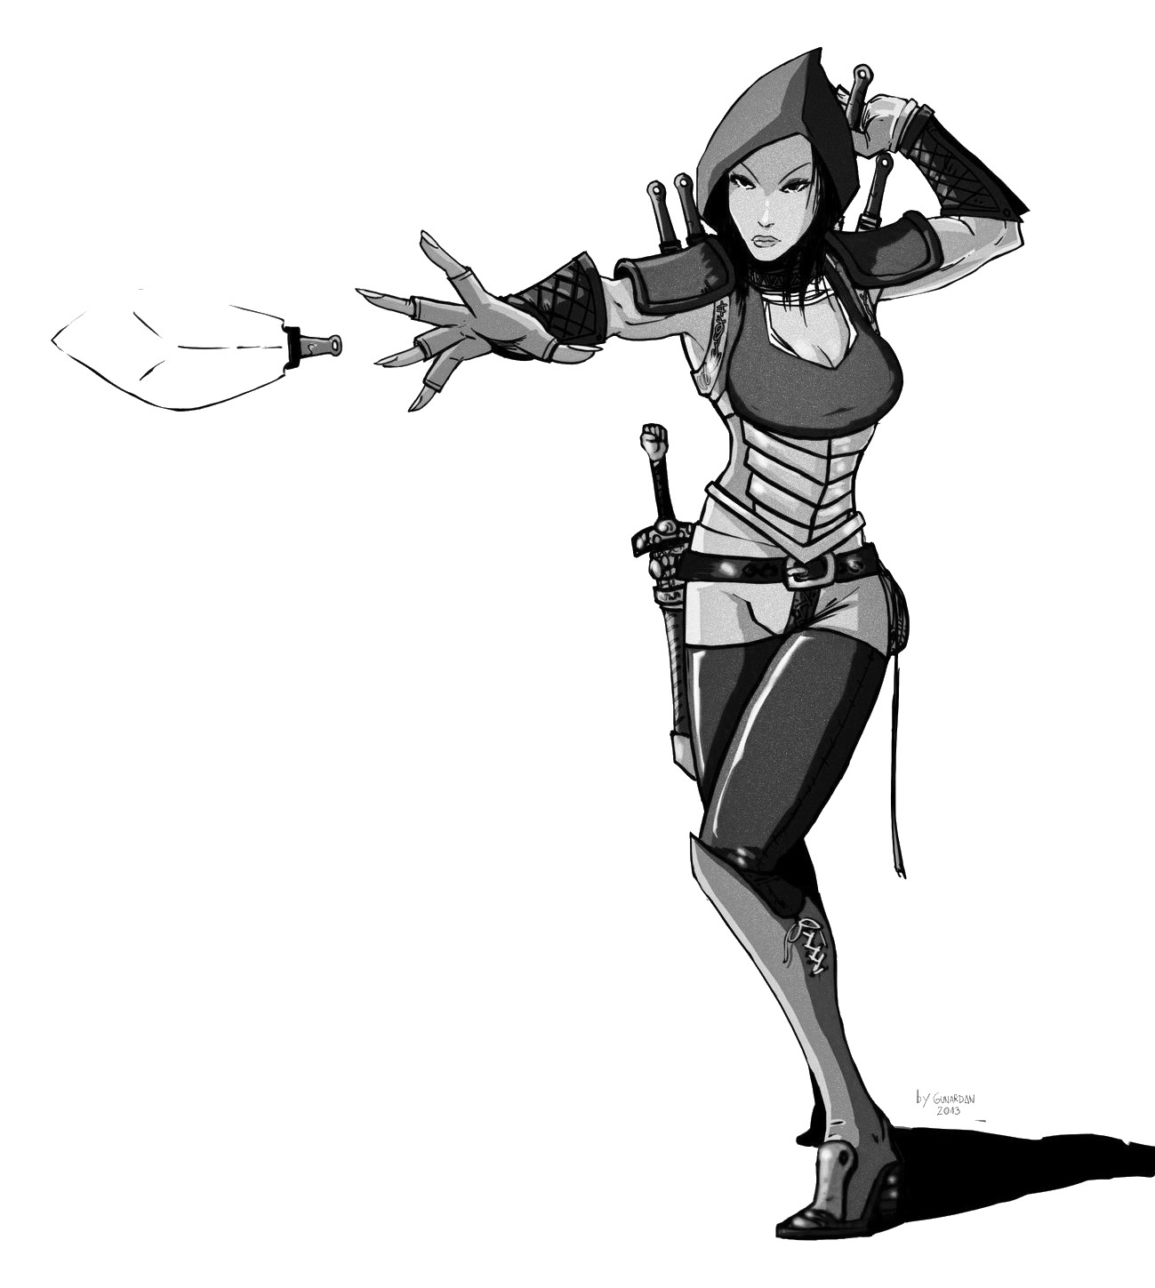
Hunters are not only capable supporting fighters – they also can track monsters, and thus prepare the party for the worst...
Hunter Advancement
Level | Exp.  Points | Hit  Dice | To  Hit | Saving Throw | Track
1 | 0 | 1 | +0 | 15 | 2
2 | 2,000 | 2 | +1 | 14 | 2
3 | 4,000 | 3 | +1 | 13 | 2
4 | 8,000 | 4 | +2 | 12 | 3
5 | 16,000 | 5 | +3 | 11 | 3
6 | 32,000 | 6 | +3 | 10 | 3
7 | 64,000 | 7 | +4 | 9 | 4
8 | 128,000 | 8 | +4 | 8 | 4
9 | 256,000 | 9 | +5 | 7 | 4
10 | 512,000 | 10 | +6 | 6 | 5

Hunter abilities
Weapons and Armor Restrictions
Hunters may use any weapon. They can't wear armor that is heavier than chain, as they need mobility.

Track
Hunters have an additional stat – Track (see the last column of the Hunter advancement table). Hunters may try to spot footsteps or other signs of monsters while in the wilderness. Whenever the Hunter checks the nearby terrain, the Referee makes a secret 1d6 roll and compares the score to the Hunter's current Track level. If the roll was equal or lower, the Referee informs the players, what creatures were here recently, where they have gone, who or what they are and how many. If the roll fails, the Referee does the same, but 50% of the information is false.

Trophies
Whenever the Hunter and his party kill a monster, he or she may take a small trophy (bone, fur, tooth...) from the corpse of that creature. The Referee tells the Hunter, what category does the trophy fit into:
- Demon
- Magical being (elemental, golem)
- Undead
- Giant (giants, bugbear, ogre)
- Draconic (kobold, dragon, wyvern)
- Greenskin (goblins, orcs, trolls)
- Animal (spiders, boars, birds)
- Underworld (troglodytes, oozes)
A Hunter can only get one trophy from each corpse. After collecting twenty trophies that fit one category, he or she is officially declared a Hunter of these type of monsters (Demon Hunter, Giant Hunter etc.). Hunters receive a +2 damage bonus, when fighting a monster from a mastered category. Hunters may have multiple titles.

Saving Throws
Hunters receive a +2 bonus on saving throws vs. poison and illusions created by wild creatures.

Slayer
A ninth or higher level Hunter may call him or herself a Slayer.
Slayers travel the world and are respected by all. Guilds and nobles always welcome Slayers, and taverns will always let such heroes stay for free.

Experience Bonus for Dexterity
Dexterity is the Prime Attribute for Hunters, which means that a Dexterity score of 15+ grants an additional 5% experience.

The Monk
Monks are martial artists that strive for bodily and spiritual perfection. They prefer to fight unarmed, unarmored and value speed over brute strength.
Monks usually travel the land in search of worthy opponents. Every monk has trained in a monastery, that has it's own rules, philosophies and fighting techniques. The Monk may not be as tough as the Fighter, but he is less encumbered, may solve some problems faster, and does not rely so much on equipment.
Monk Advancement
Level | Exp.  Points | Hit  Dice | To  Hit | Saving Throw | Martial Arts
1 | 0 | 1 | +0 | 14 | 2
2 | 2,000 | 1+1 | +1 | 13 | 2
3 | 4,000 | 2 | +1 | 12 | 3
4 | 8,000 | 2+1 | +2 | 11 | 3
5 | 16,000 | 3 | +2 | 10 | 4
6 | 32,000 | 3+1 | +3 | 9 | 4
7 | 64,000 | 4 | +3 | 8 | 5
8 | 128,000 | 4+1 | +4 | 7 | 5
9 | 256,000 | 5 | +4 | 6 | 6
10 | 512,000 | 5+1 | +5 | 5 | 6

Monk abilities
Weapons and Armor Restrictions
Monks may use any weapon, although they prefer to fight unarmed or use exotic weaponry. Monks cannot wear any armor.

Unarmed Fighting / Exotic Weapons
Monks fight using complicated and deadly martial arts. They deal 1d6 damage while fighting unarmed, and they may add their Strength, Dexterity or Wisdom bonus to their attack and damage. Furthermore, they may perform two attacks per round while fighting bare-handed. Monks also may wield all exotic weapons and gain their special bonuses (see: Page 27)

Martial Arts
Monks have a special stat: Martial Arts (check the last column in the Monk advancement table). Monks improve their AC by -X [+X], where “X” is their current Martial Arts level. They also can use their Saving Throws to dodge missiles, and get a bonus to their roll equal to their current Martial Arts.

Acrobatics
Monks may fall great distances without sustaining any damage. Furthermore, the Monk may climb (or run up) vertical walls with ease.
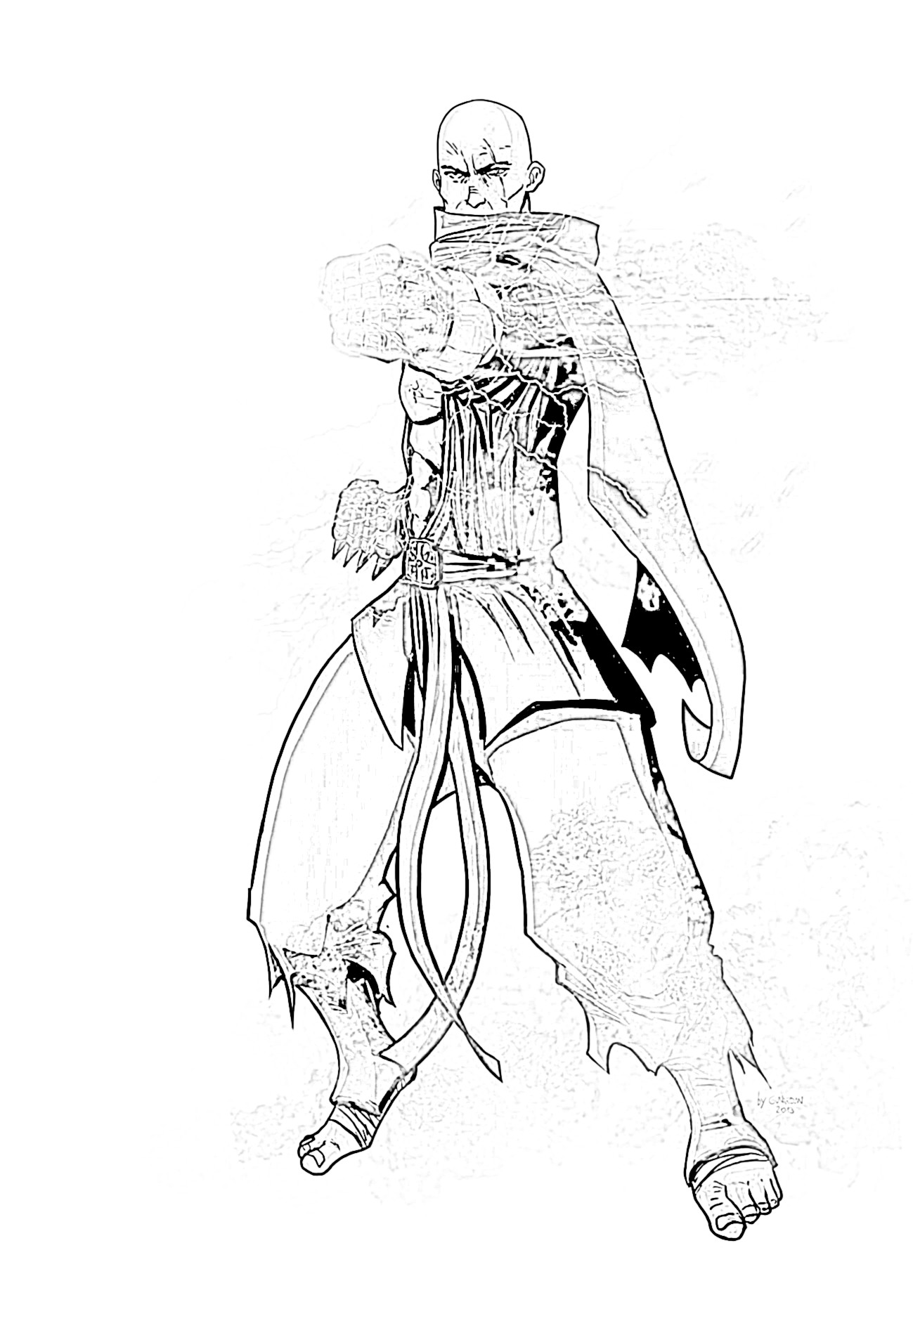
Master
A ninth or higher level Monk may call him or herself a Master and train others.
Other traveling adepts and masters may visit the monk whenever he is staying at a town or other civilized areas. Some adepts may join the monk, masters may share wisdom and rumors.

Experience Bonus for Wisdom
Wisdom is the Prime Attribute for Monks, which means that a Wisdom score of 15+ grants an additional 5% experience.

The Paladin
Paladins are holy ascetic knights of law and virtue. Fighters may fight for the sake of it, Paladins on the other hand follow a strict code – their every sword strike has a meaning and consequence. Paladins are mystical warriors that are the bane to all tyranny and evil. A lot of Paladins also serve a lawful god.
Paladins must always be lawful, although evil Black Knights (Anti-Paladins) do exist and may be chosen if the Referee agrees.
Paladin Advancement
Level | Exp.  Points | Hit  Dice | To  Hit | Saving Throw | Pride
1 | 0 | 1 | +0 | 13 | 2
2 | 2,500 | 2 | +0 | 12 | 4
3 | 5,000 | 3 | +1 | 11 | 6
4 | 10,000 | 4 | +2 | 10 | 8
5 | 20,000 | 5 | +3 | 9 | 10
6 | 40,000 | 6 | +3 | 8 | 12
7 | 80,000 | 7 | +4 | 7 | 14
8 | 160,000 | 8 | +4 | 6 | 16
9 | 320,000 | 9 | +5 | 5 | 18
10 | 640,000 | 10 | +6 | 4 | 20

Paladin abilities
Weapons and Armor Restrictions
Paladins are well-trained knights, thus they may use any weapon and wear any armor.

Vows
Paladins must always be lawful. They may only keep enough wealth to maintain themselves (and their men, at higher levels). Any excess wealth is donated to charitable or religious institutions.
As long as the Paladin maintains his vows he is immune to fear and magic that could affect his mind. If a Paladin breaks his vows – his Pride stat is also halved.

Pride
The Paladin has an extra stat – Pride (check his last column in the advancement table). He may spend his Pride points (which are restored after each rest) in two ways:
Invigorate: the Paladin may touch an ally and spend any amount of Pride, to restore them the same amount of HP.
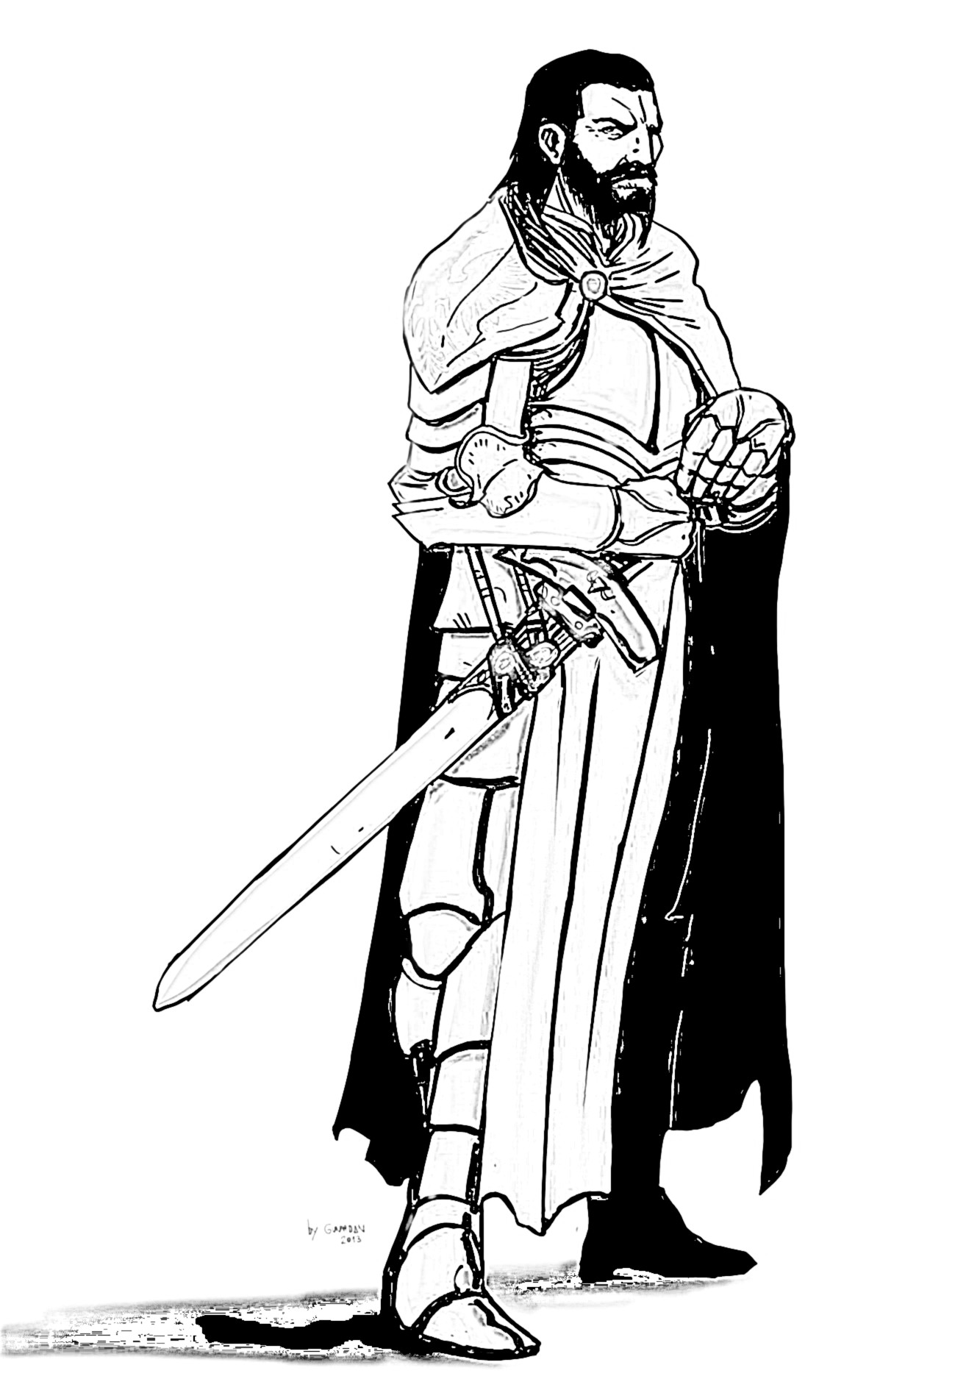
Smite: the Paladin may touch an undead or demon and spend any amount of Pride, to deal the same amount of damage to the creature (no attack roll is necessary).

Saving Throw
Paladins receive a +2 bonus on saving throws vs. any effects caused by undead and demons.

Paragon
A tenth level Paladin becomes a Paragon. At this level the Paladin may start the construction of his own order. The character may choose to attract other knights, who will fight for his or her cause.

Experience Bonus for Charisma
Charisma is the Prime Attribute for Paladins, which means that a Charisma score of 15+ grants an additional 5% experience.

Druid Spells List
Druid Spells
Level 1 | Level 2
Berries | Animal Messenger
Charm Animal | Fog
Flare | Warp Wood
Know Weather | Wild Strength
Locate Animals
Locate Snares and Pits
Level 3 | Level 4
Call Lightning | Air Walk
Protective Circle | Call Monster
Summon Animal | Tree Stride
Wind Wall
Level 5 | Level 6
Awaken Treant | ???
Quake
Sunburst
Note: if you are not using the Expanded Rules presented in this book, it would be wise to add the "Speak with Animals" and "Speak with Plants" spell to the Druid spell list.

Air Walk
Spell Level: D4
Range: Caster
Duration: 30 minutes

The Druid may walk on air, as if it was solid ground. Strong winds may break the spell.

Animal Messenger
Spell Level: D2
Range: None
Duration: Until message is delivered

The Druid summons a tiny animal in his hand (for example: bird, rat), that will try to reach it's recipient. The Druid may attach a scroll with a message to the animal. When the messenger reaches its recipient – it disappears.

Awaken Treant
Spell Level: D5
Range: Touch
Duration: Until destroyed

This spell transforms a touched tree into a friendly treant. Its HD depends on the size of the tree.

Berries
Spell Level: D1
Range: None
Duration: Until eaten

The Druid creates 1d6 magical berries in his hand. Each berry restores 1 HP when eaten. All magical berries wither at sundown.

Call Lightning
Spell Level: D3
Range: 240 ft.
Duration: Instantaneous

A lighting bolt strikes down on the chosen target and deals 1d6 damage per caster level. It deals an additional 1d6 when used outdoors, and another 1d6 if the target wears metal objects.

Call Monster
Spell Level: D4
Range: n/a
Duration: Instantaneous

This spell calls from the wild a random monster, depending on the terrain type where the spell was cast. There is a 1-2 chance, that the monster will be neutral towards the Druid. Even if hostile, the monster will always attack the enemies of the druid first.

Charm Animal
Spell Level: D1
Range: 120 ft.
Duration: Until dispelled

This spell operates in the same manner as the Charm Person spell of the Magic-User, but affects animals.

Flare
Spell Level: D1
Range: 25 ft.
Duration: Instantaneous

This spell shoots out a small magical flare out of the Druids finger. The flare may daze an enemy for 1d6 rounds (Saving Throw possible). It does not work on monsters that do not have eyes or cannot see.

Fog
Spell Level: D2
Range: 250 ft.
Duration: Until dispelled

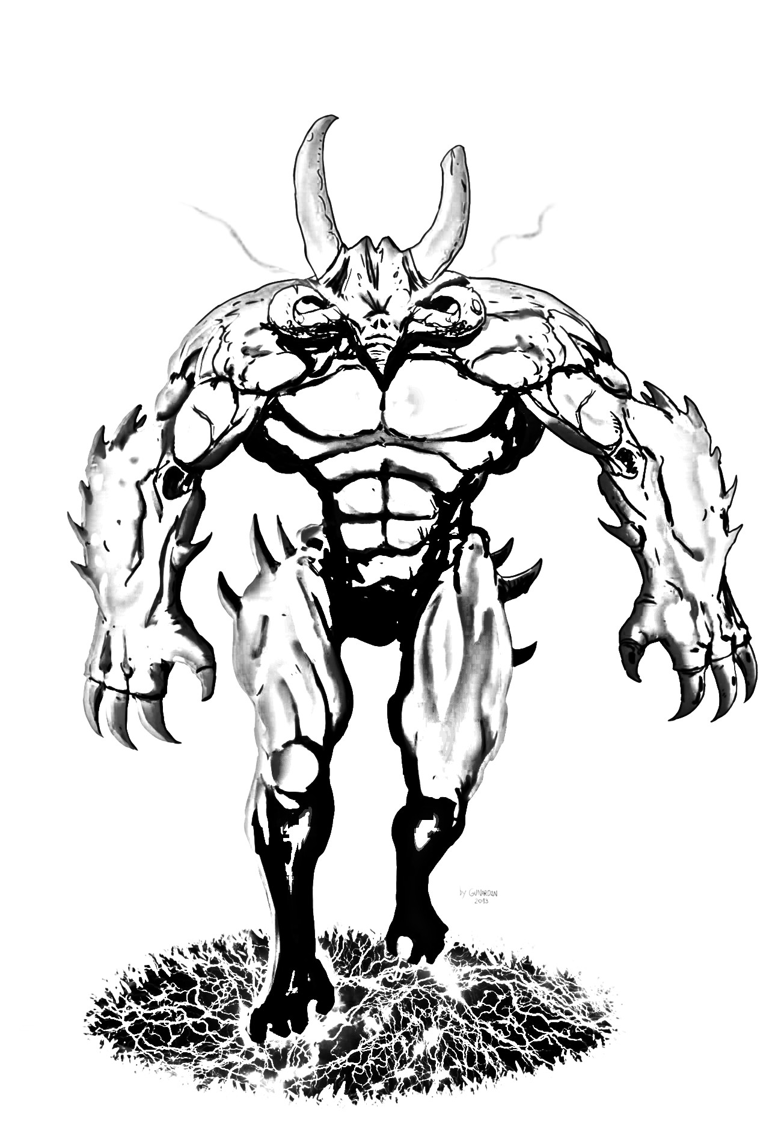
This spell creates a thick magical fog in the area. Every creature, except the Druid, can barely see in this fog and receives a -4 To-Hit penalty while trying to fight in these conditions.

Know Weather
Spell Level: D1
Range: 2 miles per caster level
Duration: Instantaneous

This spell allows the Druid to forecast the weather in the current location. The forecast is for the next 12 hours.

Locate Animal
Spell Level: D1
Range: 90 ft.
Duration: 1 minutes per level

Works in the same manner as the Locate Object spell, but affects animals.

Locate Snares and Pits
Spell Level: D1
Range: 90 ft.
Duration: Instantaneous

Works in the same manner as the Find Traps spell, but affects snares and pits.

Protective Circle
Spell Level: D3
Range: 20 ft.
Duration: 2 minutes per caster level

This spell creates a stationary magical circle around the Druid, that completely blocks fire, lightning, water and ice.

Quake
Spell Level: D5
Range: 600 ft.
Duration: up to 1 minute/round per caster level

This spell creates a mighty tremor, that destroys structures, collapses tunnels and opens cracks in the ground. All creatures (except the druid) in range also fall on the ground and can't act, as long as the druid keeps casting the spell (see Duration).

Summon Animal
Spell Level: D3
Range: 90 ft.
Duration: 1 day

This spell calls forth an animal ally with 4 HD. The Druid may also instead divide the HD into smaller creatures (for example: he may summon four animals with 1 HD). All summoned animals disappear at the end of the day.

Sunburst
Spell Level: D5
Range: 300 ft.
Duration: Instantaneous

This spell creates an explosive globe (80 ft.) of light. All creatures within the globe become blinded and take 1d6 points of damage per caster level.

Tree Stride
Spell Level: D4
Range: Caster
Duration: 1 hour per caster level

This spell allows the Druid to merge (hide inside) with a tree. After merging, the Druid can freely “teleport” into another nearby tree of the same type.
The Druid must leave the tree if the spell duration ends, or the tree is chopped down, or burned.

Warp Wood
Spell Level: D2
Range: 30 ft.
Duration: Permanently

This spell causes wood to bend and warp, permanently destroying its straightness, form, and strength. A warped door springs open (or becomes stuck, requiring a Strength check to open, at your option). A boat or ship springs a leak. Warped ranged weapons are useless. Alternatively, you can unwarp wood (effectively warping it back to normal) with this spell, straightening wood that has been warped by this spell or by other means.

Wild Strength
Spell Level: D2
Range: Caster or Touch
Duration: 1 hour per caster level

This spell gives a chosen person immense strength – his muscle mass rips apart clothes after casting. The character also receives a +2 bonus to all melee damage done and can easily bend bars and lift heavy objects.

Wind Wall
Spell Level: D3
Range: 100 ft.
Duration: 1 round per caster level

This spell creates an invisible curtain of air, that deflects all projectiles, gases, and smaller creatures (HD 1/2). Creatures with a HD of 1+ may still try to breach the wall, but must make a Saving Throw in order to do so.

Expanded Rules
This chapter presents rules that I personally use in my campaign. As you may notice, they change a lot in the original White Box – thanks to these house rules characters are much stronger and players have more options to choose from while creating their characters.
Overall, these rules are designed for long campaigns, and for players who like to tinker with game mechanics.

Attributes
Attributes are handled differently in my game. While creating their characters, players roll seven times 3d6 and drop the lowest score. After that, they may arrange the rolls however they want.

Attribute Bonuses and Effects
In these rules, Attributes scores may give high bonuses to the character.
Attribute Bonus
Attribute Roll | Bonus
3 | -3
4-5 | -2
6-8 | -1
9-11 | 0
12-14 | +1
15-16 | +2
17-18 | +3
19+ | +4

Strength: characters use their Strength Bonus to modify their “to-hit” and damage results when using melee weapons.
Dexterity: characters use their Dexterity Bonus to modify their “to-hit” and damage results when using ranged weapons.
Constitution: characters add their Constitution Bonus when rolling their Hit Die.
Intelligence: Magic-Users can use their Intelligence Bonus to improve “spell effectiveness” (i.e. target suffers a loss on his saving throw). Every “+” in the Intelligence Bonus also allows the character to learn an additional language. Characters with low intelligence cannot solve puzzles.
Wisdom: Clerics can use their Wisdom Bonus to improve “spell effectiveness” (i.e. target suffers a loss on his saving throw). Every “+” also gives the character a +5% bonus to all XP gained, and every “-” gives a -5% penalty to all XP gained.
Charisma: each character in the game may hire up to three specialists, where the Charisma Bonus defines their numbers. The Charisma Bonus also modifies Loyalty, Morale and Reaction rolls.

Bonus XP
If you wish to use the rules that are presented here, ignore all the Experience Bonus abilities of all classes - Characters do not receive Bonus XP for having high Attribute Scores (so, the Fighter does not receive bonus XP for having high Strength). Bonus XP is covered by the Wisdom attribute, and there are no Prime Attributes.

Checks
While traveling in dungeons or in the wilderness, characters may perform various actions, this includes: Listening, Finding Secret Doors, Finding Traps and Unlocking Doors. Whenever a character performs one of these actions, the Referee secretly rolls a d6. A result of 1-2 means success, anything above is failure. Some racial abilities and feats may modify these rolls.

Critical Hits and Failures
Rolling a 20 on an Attack Roll results in a Critical Hit – the character deals maximum damage to his foe. Rolling a 1 means a Critical Failure – the character deals no damage and slips or drops his weapon in the process.

Dual-Wielding
Characters may wield two weapons at once. Dual-Wielding is simply the opposite of fighting with a weapon + shield. Instead of gaining AC, the character gets a +1 To-Hit Bonus. All attacks are still made with the weapon in the main hand.

Less Harsh Deaths
Characters die when they reach negative Hit Points equal to their level. When a character's HP reaches 0, he or she is unconscious and loses 1 HP per combat round due to bleeding. During that time, the party may stop the bleeding.

Attribute Improvement
Upon reaching level two, four, six, and eight, characters may choose two different attributes and increase them by one. Remember to recalculate Hit Points, if the Constitution Bonus of a character has increased.

Exotic Weapons
Characters may find exotic weaponry on their journeys. Exotic weapons are basically more expensive (gp cost x3) and complicated versions of the traditional White Box weapons. Below is a short list of exotic weapons you may find. It works like this: whenever a character finds a weapon, there is a 25% chance, that this weapon will be exotic instead (for example: if you would find a staff, there is a 25% chance you will get a nunchaku instead).
Nunchaku (Staff) – two sticks connected with a chain. It's hard to use, so only Monks may wield it, and they also receive 5% more XP whenever they defeat an enemy with a nunchaku.
Meteor Hammer (Warhammer) – two heavy iron balls connected with a chain. Monks deal additional +1 damage with this weapon. Requires two hands to use.
Butterfly Sword (Sword, short) – the butterfly sword has a small crossguard to protect the hands of the wielder. Monks improve their AC by -1 [+1] if they dual wield these.

Races
Races in my campaign work differently. Players may choose any race and class combination, as long as it makes sense. Each race has it's own special abilities:
- Human: humans are quick to learn – they may choose a feat during character creation.
- Dwarf: dwarfs are tough and sturdy – their Hit Dice is a d8 instead of a d6. Dwarfs also receive a +1 To-Hit Bonus when fighting goblins, orcs and trolls.
- Elf: elves are immune to paralysis (for example, caused by ghouls). Elves can also Listen and Find Secret Doors more easily – their range of success is increased by 2 (1-4 instead of 1-2).
- Halfling: halflings are small, thus big monsters (ogres, trolls, giants...) can barely hit them – they deal only half of their damage (rounded down). Halflings also move completely silently on grass.
- Gnome: gnomes can always recognize illusions. They can also communicate with burrowing animals.
- Half-Orc: half-orcs get a +1 damage bonus to all attacks they perform (ranged and melee). They also can Unlock Doors (by using pure Strength) more easily – their range of success is increased by 2 (1-4 instead of 1-2).

Additional Abilities
Each character class in my game has an additional ability. Some of them give options during character creation.

Bard
Bardic Spell
Bards have some understanding of mystical scriptures. During character creation, choose one first-level spell from the Magic-User list. You may cast that spell once per day.

Cleric
God's Weapon
Every god has it's preferred weapon. During character creation, the cleric should describe which weapon is used by his or her god (warhammer, long swords etc.).
The cleric has proficiency in his chosen weapon. Furthermore, he receives a +1 To-Hit and Damage bonus when using it.

Druid
Animal Tongue
Druids may naturally speak with any animal. Not all of them must be friendly or helpful though.

Hunter
Monster Expert
At any point in their career, the Hunter may choose a monster category he became a Slayer of, and declare that he or she is an Expert on that type of monsters (ex. Demon Expert, Animal Expert).
A Hunter may do this only once, and he must be already a Slayer of those monsters. Experts can always track their chosen monsters (no roll is necessary), and they may always ask the Referee about their HD, AC and abilities.

Fighter
Sub-classes
The fighter may choose one subclass, which represents his fighting style or origin.
- Anti-mage: Anti-Mages are immune to magic, but can't use magic items and drink potions.
- Archer/Crossbowman/Slinger: during a ranged attack, this Fighter may simply attack with a +2 To-Hit Bonus or he or she may try to attack a vital spot and deal additional 2 points of damage to the enemy.
- Berserker: before every fight, the Berserker may go frenzy and reduce his Armor Class by +4 [-4] during the battle. While in frenzy, the Berserker may perform an additional attack every round.
- Mercenary: Mercenaries are tough fighters. Whenever they roll a “1” on their damage roll, when fighting with a two-handed melee weapon, they may re-roll. The second result is final.
- Guardian: whenever a nearby (up to 2 feet) character would receive damage from an enemy, the Guardian may redirect all that damage to himself.
- Soldier: at the start of their round, Soldiers may yell orders at their party. If they do – they may choose one ally and give him or her a +1 bonus to their To-Hit and damage during their next turn. Soldiers are also harder to kill – they do not lose consciousness, if their HP falls to 0 or lower (they still die, if it reaches the negative number equal to their level).
- Swordsman: when fighting with a blade, Swordsmen receive a +1 To-Hit and Damage Bonus and they may use their Dexterity bonus instead of Strength to calculate attack and damage. They also improve their AC by their Dexterity Bonus (for example, a +2 Dexterity means a -2 [+2] bonus to AC). Swordsmen cannot wear any armor heavier than leather.

Magic-user
Familiar
Wizards may have their own familiar. Familiars are small (1 HD, AC 8 [11]), magical creatures that support the magician. During character creation describe your familiar (is it a cat? Owl? Raven?) and give him a name.
The Magic-User has a telepathic connection with his familiar. The familiar can also speak all languages known to the Magic-User and knows one first level spell (he or she may cast it once per day).
If the familiar dies, the Magic-User decreases his or her Intelligence score by 1. The familiar may be re-summoned after a week (the Magic-User also restores his or hers lost Intelligence).

Monk
Meditation
Once per day, the monk may go into a deep meditative state for one hour. After that, the monk restores Hit Points equal to his Martial Arts level, and his body is purified from poisons.

Paladin
Paladin Mount
While in the wilderness, the Paladin may whistle and call his steed (HD 4) for aid. During character creation, the player should describe his mount and name it.
If the steed dies, the Paladin decreases his or her Charisma by 1 and must wait one year until he or she finds a new steed (the Paladin also restores his or hers lost Charisma).

Thief
Precision
When using daggers, the Thief may use his Dexterity Bonus instead of his Strength bonus when calculating damage and To-Hit bonuses.

Feats
On the third, fifth, seventh, and ninth level, the player may choose one special feat for his character. He or she may choose a General Feat or one from their class list.

General Feats
- Careful – Listening, Finding Secret Doors and Finding Traps range of success is increased by 1.
- Gifted – increase one chosen Attribute by 2.
- Leadership - +2 to maximum specialists you can hire.
- Linguistics – you learn two new languages.
- Fortune – once per game, you may re-roll any dice roll, even that done by an enemy, and choose any of the two results.
- Tough – +1 to all damage dealt and Unlocking Doors range of success is increased by 1.

Bard Feats
- Charming – while trying to charm creatures, you are treated as a bard of one level higher.
- Golden Tongue – you learn a new language, and you may also choose obscure languages, like draconic, demonic, ancient...
- Light Step – you activate traps only when the Referee rolls 1 on a d6. Your AC also improves by -1 [+1].
- Simple Counter-Spells - +3 to Saving Throws vs. Magic.
- Fencer – when you attack with a sword, you may add a +2 To-Hit bonus to your attack. If you don't – you improve your AC by -2 [+2] until your next turn.
- Wise – increase your Lore by 1.

Cleric Feats
- Conversion – you may forget any prepared spell and cast cure/cause light wounds instead.
- Fearless – you are immune to fear.
- Holy Aura – all damage you receive is reduced by 2.
- Spell Specialization – choose one spell up to level three from your list that you know. You may cast that spell once per day for free.
- Stronger Turning – while turning undead, you are treated as a cleric of one level higher.
- Talent – you can prepare one extra first level spell.

Druid Feats
- Beast – +2 to damage while in your big animal form.
- Body Alchemy – +3 to Saving Throws vs. poisons and diseases.
- Natural Armor – your AC is improved by -2 [+2] when standing in mud, tall grass or water.
- Spell Specialization – choose one spell up to level three from your list that you know. You may cast that spell once per day for free.
- Staff Fighter – +1 to damage and To-Hit when fighting with a staff. Your AC also improves by -2 [+2] when wielding this weapon.
- Talent – you can prepare one extra first level spell.

Hunter Feats
- Ghost – as long as your are in a thicket, in water or buried in mud, you are treated as invisible to your enemies, until you make an attack. Even after you show yourself, your AC is still improved by -1 [+1] as long as you hold your position.
- Tracker – +1 to Tracking.
- Hunting Company – if you successfully managed to track down some monsters, you and your party receive a +1 To-Hit and damage bonus while fighting them.
- Quick shot – you may re-roll any of your damage rolls, when attacking with a bow, sling or crossbow. Your second result is however final.
- Quick stab – you may re-roll any of your damage rolls, when attacking with a spear. Your second result is however final.
- Life Reader – you may always ask the Referee about the remaining HP of a visible creature.

Fighter Feats
- Cleave – you may perform another attack after killing an enemy.
- Dodge Mastery – your AC is improved by -1 [+1].
- Eagle Eye – you always choose the target when firing a ranged weapon into melee (you can't harm your allies, unless you choose to).
- Iron Will – you receive +2 to all Saving Throws.
- Persistence – your maximum Hit Points are increased by 1 per Fighter level.
- Weapon Specialist – choose a weapon type (swords, axes, hammers...). +1 To-Hit and Damage Bonus when using the chosen weapon.

Magic-User Feats
- Battle Mage – add 1d6 to damage dealt by your spells.
- Gesture Magic – you don't need to speak while casting spells.
- Magic Aura – you have an invisible magic shield, that improves your AC by -2 [+2].
- Spell Specialization – choose one spell up to level three from your list that you know. You may cast that spell once per day for free.
- Talent – you can prepare one extra first level spell.
- Vocal Magic – you don't need to move while casting spells.

Monk Feats
- Exotic Fighter – +1 to damage and To-Hit while fighting with exotic weapons (nunchaku, meteor hammers, butterfly swords).
- Iron Knuckles – +1 to damage done by unarmed strikes. Your hands are also treated as a magical weapon.
- Nirvana – you restore 1d6 HP after each won battle.
- Slow Motion – +1 to Saving Throws while trying to dodge missiles. Your AC also improves by -1 [+1].
- Vital Strikes – your first unarmed attack always targets the vital points of your enemy. Your opponent must make a SV, if he or she was damaged – if it fails, he or she is paralyzed for 1d6 turns.
- Water Walk – you can run on water (you can't however stand on water – you can't end your turn on water during battle).

Paladin Feats
- Blessed – you may cast the “Bless” and “Detect Chaos” each once per day.
- Crusader - +2 to damage against undead and demons (this also increases the damage done by smiting).
- Inspiring Leader – choose an ally at the start of your each turn. He or she receives +1 to damage dealt and To-Hit until your next turn.
- Inspiring Protector – choose an ally at the start of your each turn. He or she improves their AC by -2 [+2] until your next turn.
- Questing Knight – +2 to Pride.
- Witch Hunter – all magic damage you receive is halved (rounded down), and you can identify spells (you always know what spells are being cast and what is their effect).

Thief Feats
- Assassin – add +4 to your To-Hit bonus instead +2 when you perform a Back Stab.
- Delver – Listening, Finding Secret Doors and Finding Traps range of success is increased by 1.
- Iron Fangs – improve your AC by -2 [+2] if you wield a dagger or two daggers.
- Night Owl – add +1 to your parties initiative roll.
- Risky – you achieve Critical Hits on scores of 19 and 20.
- Specialist – increase your Thievery by 1.

OPEN GAME LICENSE Version 1.0a
The following text is the property of Wizards of the Coast, Inc. and is Copyright 2000 Wizards of the Coast, Inc ("Wizards"). All Rights Reserved.
1. Definitions: (a)"Contributors" means the copyright and/or trademark owners who have contributed Open Game Content; (b)"Derivative Material" means copyrighted material including derivative works and translations (including into other computer languages), potation, modification, correction, addition, extension, upgrade, improvement, compilation, abridgment or other form in which an existing work may be recast, transformed or adapted; (c) "Distribute" means to reproduce, license, rent, lease, sell, broadcast, publicly display, transmit or otherwise distribute; (d)"Open Game Content" means the game mechanic and includes the methods, procedures, processes and routines to the extent such content does not embody the Product Identity and is an enhancement over the prior art and any additional content clearly identified as Open Game Content by the Contributor, and means any work covered by this License, including translations and derivative works under copyright law, but specifically excludes Product Identity. (e) "Product Identity" means product and product line names, logos and identifying marks including trade dress; artifacts; creatures characters; stories, storylines, plots, thematic elements, dialogue, incidents, language, artwork, symbols, designs, depictions, likenesses, formats, poses, concepts, themes and graphic, photographic and other visual or audio representations; names and descriptions of characters, spells, enchantments, personalities, teams, personas, likenesses and special abilities; places, locations, environments, creatures, equipment, magical or supernatural abilities or effects, logos, symbols, or graphic designs; and any other trademark or registered trademark clearly identified as Product identity by the owner of the Product Identity, and which specifically excludes the Open Game Content; (f) "Trademark" means the logos, names, mark, sign, motto, designs that are used by a Contributor to identify itself or its products or the associated products contributed to the Open Game License by the Contributor (g) "Use", "Used" or "Using" means to use, Distribute, copy, edit, format, modify, translate and otherwise create Derivative Material of Open Game Content. (h) "You" or "Your" means the licensee in terms of this agreement.
2. The License: This License applies to any Open Game Content that contains a notice indicating that the Open Game Content may only be Used under and in terms of this License. You must affix such a notice to any Open Game Content that you Use. No terms may be added to or subtracted from this License except as described by the License itself. No other terms or conditions may be applied to any Open Game Content distributed using this License.
3.Offer and Acceptance: By Using the Open Game Content You indicate Your acceptance of the terms of this License.
4. Grant and Consideration: In consideration for agreeing to use this License, the Contributors grant You a perpetual, worldwide, royalty-free, non-exclusive license with the exact terms of this License to Use, the Open Game Content.
5.Representation of Authority to Contribute: If You are contributing original material as Open Game Content, You represent that Your Contributions are Your original creation and/or You have sufficient rights to grant the rights conveyed by this License.
6.Notice of License Copyright: You must update the COPYRIGHT NOTICE portion of this License to include the exact text of the COPYRIGHT NOTICE of any Open Game Content You are copying, modifying or distributing, and You must add the title, the copyright date, and the copyright holder's name to the COPYRIGHT NOTICE of any original Open Game Content you Distribute.
7. Use of Product Identity: You agree not to Use any Product Identity, including as an indication as to compatibility, except as expressly licensed in another, independent Agreement with the owner of each element of that Product Identity. You agree not to indicate compatibility or co-adaptability with any Trademark or Registered Trademark in conjunction with a work containing Open Game Content except as expressly licensed in another, independent Agreement with the owner of such Trademark or Registered Trademark. The use of any Product Identity in Open Game Content does not constitute a challenge to the ownership of that Product Identity. The owner of any Product Identity used in Open Game Content shall retain all rights, title and interest in and to that Product Identity.
8. Identification: If you distribute Open Game Content You must clearly indicate which portions of the work that you are distributing are Open Game Content.
9. Updating the License: Wizards or its designated Agents may publish updated versions of this License. You may use any authorized version of this License to copy, modify and distribute any Open Game Content originally distributed under any version of this License.
10 Copy of this License: You MUST include a copy of this License with every copy of the Open Game Content You Distribute.
11. Use of Contributor Credits: You may not market or advertise the Open Game Content using the name of any Contributor unless You have written permission from the Contributor to do so.
12 Inability to Comply: If it is impossible for You to comply with any of the terms of this License with respect to some or all of the Open Game Content due to statute, judicial order, or governmental regulation then You may not Use any Open Game Material so affected.
13 Termination: This License will terminate automatically if You fail to comply with all terms herein and fail to cure such breach within 30 days of becoming aware of the breach. All sublicenses shall survive the termination of this License.
14 Reformation: If any provision of this License is held to be unenforceable, such provision shall be reformed only to the extent necessary to make it enforceable.
15 COPYRIGHT NOTICE
Open Game License v 1.0 Copyright 2000, Wizards of the Coast, Inc.

